# Assigment lab 1

## Creating bucket

Creating buckets can be done in the S3 tab.

Properly naming and picking the correct region.

## Creating files

Create the files and upload

## Making file publicly accessible

Enable ACLs on the bucket:

Check if the file is available:

Other files aren’t available:

Enable Versioning

Edit the file by downloading it, making changes and uploading it again.

The versions are visible through the versioning tab.

To roll back the version, download the latest version you want and reupload it, or delete the newer version until that one is the newest.

Delete the object:

Delete file completely:

Versioning can not completely be turned off, only suspended:

## Replicate to another region:

It is used to copy objects across Across S3 buckets in different AWS regions.

Create a bucket in a different region:

Add replication rule only to specific folder:

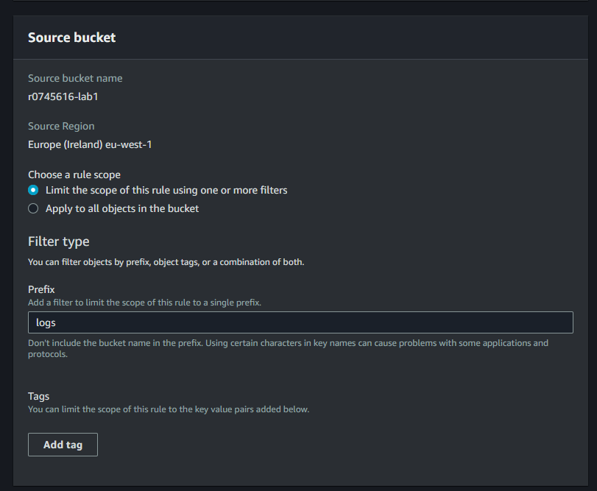

Choose the newly created bucket:

Existing files are not replicated automatically.

Old versions will not be replicated.

New versions will be replicated.

New files will be added automatically.

Will be deleted from both buckets (versioning will keep old versions).

Delete markers will also be replicated.

## Create lifecycle rule

Make new rule:

Define lifecycle rule actions:

The minimum time for the Standard-IA is 30 days and glacier 100 days.

## Encryption

Encryption is now on by default:

Yes this changes nothing about visibility.

## CLI copy

Can be done with a simple command:

aws s3 cp .\01.txt s3://r0745616-lab1/logs/mar/01.txt.



They are replicated automatically.

Overwrite the file:

aws s3 cp .\01.txt s3://r0745616-lab1/logs/jan/01.txt

The old versions will still be there.

### Batch script

Here is the example bash script to create a bucket.

aws s3api create-bucket --bucket $name --region us-east-1

aws s3api put-object --bucket test-bash-2 --key logs/jan/02.txt --body logs/jan/02.txt

aws s3api put-object --bucket test-bash-2 --key logs/jan/01.txt --body logs/jan/01.txt

aws s3api put-bucket-versioning --bucket $name --versioning-configuration Status=Enabled

## Static site

The files need to be set publicly accessible, as done earlier.

The static page:

The error page:

The URL of the site:  
<http://site-bucket-r0745616.s3-website-eu-west-1.amazonaws.com>

## Bash Static Site Script

aws s3api create-bucket --bucket %1 --create-bucket-configuration LocationConstraint=eu-west-1 --object-ownership BucketOwnerPreferred

aws s3api put-public-access-block --bucket %1 --public-access-block-configuration "BlockPublicAcls=false,IgnorePublicAcls=false,BlockPublicPolicy=false,RestrictPublicBuckets=false"

aws s3api put-bucket-acl --bucket %1 --acl public-read

aws s3 cp index.html s3://%1

aws s3 cp error.html s3://%1

aws s3api put-object-acl --bucket %1 --key index.html --acl public-read

aws s3api put-object-acl --bucket %1 --key error.html --acl public-read

aws s3 website s3://%1 --index-document index.html --error-document error.html

echo Website address: http://%1.s3-website-us-east-1.amazonaws.com

## Python Script

A python script that logs processor usage, and hosts it as a static web site:

import datetime  
import boto3  
import psutil  
from botocore.exceptions import NoCredentialsError  
  
  
# Function to log CPU usage  
def log_cpu_usage():  
 cpu = []  
 for _ in range(10):  
 cpu_percent = psutil.cpu_percent(interval=1)  
 cpu.append(cpu_percent)  
 return cpu  
  
  
# Function to create an HTML file with CPU usage data  
def create_html_report(cpu):  
 with open('results.html', 'w') as f:  
 f.write("<html><body>")  
 f.write("<h1>CPU Usage Report</h1>")  
 f.write("<ul>")  
 for idx, usage in enumerate(cpu):  
 f.write(f"<li>Second {idx + 1}: {usage}%</li>")  
 f.write("</ul>")  
 f.write("</body></html>")  
  
  
# Function to upload the HTML file to S3  
def upload_to_s3(html_file):  
 s3 = boto3.client('s3')  
 bucket_name = 'r0745616-lab1'  
 key = 'results.html'  
  
 # Set the content type to text/html  
 extra_args = {'ContentType': 'text/html'}  
  
 try:  
 s3.upload_file(html_file, bucket_name, key, ExtraArgs=extra_args)  
 print(f"Uploaded {html_file} to S3 bucket: {bucket_name}/{key}")  
 make_public(s3, bucket_name, key)  
 allow_static_site(s3, bucket_name, key)  
 except FileNotFoundError:  
 print(f"The file {html_file} was not found.")  
 except NoCredentialsError:  
 print("AWS credentials not found.")  
  
  
# Function that makes the file publicly accessible through a web browser  
def make_public(s3, bucket_name, key):  
 s3.put_object_acl(  
 Bucket=bucket_name,  
 Key=key,  
 ACL='public-read'  
 )  
  
  
# Changes the bucket properties so it hosts results.html as a static site  
def allow_static_site(s3, bucket_name, key):  
 s3.put_bucket_website(  
 Bucket=bucket_name,  
 WebsiteConfiguration={  
 'IndexDocument': {'Suffix': key},  
 }  
 )  
  
  
if __name__ == "__main__":  
 cpu_usage = log_cpu_usage()  
 create_html_report(cpu_usage)  
 upload_to_s3('results.html')